Intrusion-related mineral systems in north-east Queensland

Courteney Dhnaram and Vladimir Lisitsin
Geological Survey of Queensland, PO Box 15216, City East, Brisbane, QLD 4002
Key Words: gold, copper, tin, intrusion-related, north-east Queensland, mineral systems, Permian, Carboniferous

Introduction
Intrusion-related mineral systems in north-east Queensland have produced the most of the major recently worked gold bearing ore bodies within the state (Kidston, Mt Leyshon and Red Dome). However these deposits are poorly understood in a regional context, thus hindering explorers in the area finding new deposits to replace previous gold and base metal production.
The only way of replacing this lost production is to re-invigorate exploration through new discoveries and the development of new exploration concepts and methodologies that would assist current explorers and bring new players to the region.
The purpose of this paper is to highlight the significant and distinctive character of the Carboniferous to Permian Kennedy Igneous Association (KIA) and associated Intrusion-related mineral systems within north-east Queensland and to discuss current Geological Survey of Queensland (GSQ) projects and funding initiatives aiming to reinvigorate mineral exploration in the region.
Geology
The Kennedy Igneous Association is the distinctive feature of north Queensland geology especially in relation to intrusion-related mineral systems. The main part of the igneous association is in the Townsville-Chillagoe region straddling the southern boundary of the Hodgkinson and Broken River Province (Mossman Orogen), but extending south-east into the northern part of the Drummond Basin and northwest undercover to Mornington Island in the Gulf of Carpentaria (Figure 1). There are significant extensions along south-west-trending belts in the Georgetown, Broken River and Charters Towers Provinces and outliers in the Hodgkinson Province and on Cape York Peninsula. The Kennedy Igneous Association as defined by Champion and Bultitude (2013) no longer include the Carboniferous to Permian intrusive and volcanic rocks within the Connors Subprovince which are considered to be part of the New England Orogen.
The Kennedy Igneous Association consists of Early Carboniferous to mid Permian (345-260ma) predominately felsic igneous rocks with roughly equal proportions of volcanic and plutonic rocks in the Townsville- Mornington Island Belt (TMIB) and significant sub-volcanic complexes particularly in the adjacent provinces. The volcanic domains are dominated by cauldron subsidence complexes like the Newcastle Range Volcanic Group near Georgetown and the Featherbed Volcanic Group north-west of Chillagoe and the plutons are amalgamated into a semi-coherent batholith exposed mainly in its roof zone along the TMIB (Figure 2). The intrusions are mostly I-type, with A-type and I-type intrusions forming later in Permian. The associated metallogeny of the Kennedy Igneous Association is Au-Sn-W-U; unlike the New England Orogen (NEO) with the metallogeny is Cu-Mo-Au (Figure 2). The geodynamic environment of the Kennedy Igneous Association magmatism is not well understood, in particular the variation in trends from north to south and north-west to south-east but it is believed that the widespread volcanic cauldron complexes were initiated by, and formed in response to, regional extensional events (Champion and Bultitude, 2013).

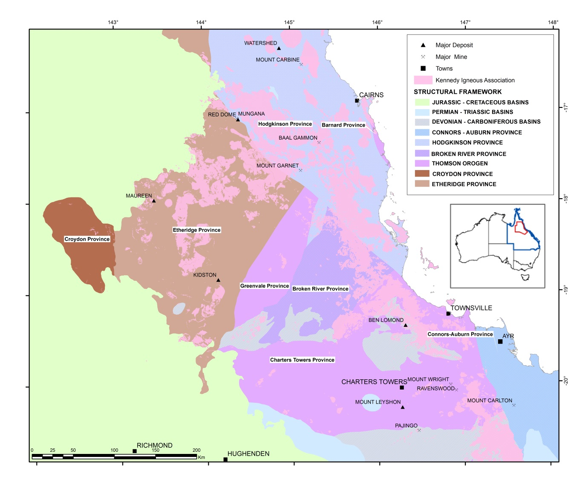 Figure 1: Tectonic provinces of northeast Queensland after Withnall & others, 2013.

Mineralisation
Widespread mineralisation occurs associated with Kennedy Igneous Association felsic (mostly intrusive) magmatism in northern Queensland, encompassing a variety of mineralisation styles, including Sn-W, intrusion-related gold (± Mo, Bi, W), epithermal Au ± Ag, intrusion-related U-F-Mo and possibly porphyry Cu-Au mineralisation (Kositcin and others, 2009).
Although much of the mineralisation is of small size, significant deposits exist for most styles within north Queensland. What is evident from the region is that deposit styles, although varied, largely relate to the same tectonic and magmatic events, with mineralisation styles and commodity types more related to magmatic controls such as granite composition, redox state, and degree of fractionation, as pointed out by Blevin and co-workers (Blevin, 2004, 2010; Champion & Blevin, 2005) specifically related to north Queensland magmatism.
Two end-members for intrusion-related gold systems (IRGS) are porphyry Au/Cu-Au deposits associated with primitive oxidised magmas largely in primitive tectonic settings (e.g. Macquarie Arc deposits in NSW), and the intrusion-related gold (IRG) end-member with more evolved, more reduced magmas, largely in continental settings, which is seen within north Queensland. Many IRG deposits in Australia have associated early high temperature molybdenum (Mo-W-Bi) mineralisation with, typically, more distal gold (Blevin, 2010) and research over the last 25 years has focused on producing regional models which reflect the known IRG systems with north Queensland. A recent compilation of the IRGS within north Queensland by Morrison, Lisitsin and Dhnaram (2015) has focused on the geochemical zonation (both laterally and vertically), mineralisation styles and metal associations of specific IRG deposits within the region.
Tin-tungsten mineralisation with the region is clearly related to the associated granites in both age and geochemistry, with most of the Sn-W mineralisation located in the Herberton region within the Hodgkinson Province. As shown by Champion & Blevin (2005) there is a clear strong relationship in North Queensland between Sn mineralisation and strongly fractionated, reduced I- and S-type granites.
The most recent discovery within north Queensland which has developed into a major operating mine is the Mount Carlton operation, within the northern Bowen Basin (Connors Subprovince), which can now be considered as a potential new ‘province’ for high sulfidation epithermal deposits. However, this greenfield discovery is an exception, as most production from the KIA is from companies continuing to mine extensions of known mineralisation (e.g Sarsfield/Buck Reef West operation in Ravenswood) or retreating tailings from previous mining operations (e.g. Mount Carbine).
Some of the challenges facing explorers when looking for intrusion-related mineral systems within north Queensland include the lack of current data and understanding related to:
- the spatial extents of specific intrusion-related mineral systems and their geochemical variants and how these systems zone laterally and vertically – which also relates to recognising potential at depth
- lack of geochronology of metallogenic and associated magmatic events across the region and how certain time periods within the Kennedy Igneous Associated may be more favourable for mineralisation
- distinguishing barren, poor and rich systems and districts
- the lack of consistent validated regional metallogenic datasets available, including geochemistry, knowledge of shallow intrusions and solid geology

New research is focusing on determining the spatial relationships between the outcropping KIA and known mineral deposits, as most mineral deposits are not located within the main igneous centres but within older geological provinces, sometimes with no obvious source intrusion (Figure 2). This highlights the need to extend exploration technologies beyond the use of geological maps into more sophisticated studies of alteration zoning at surface and geophysical signatures.
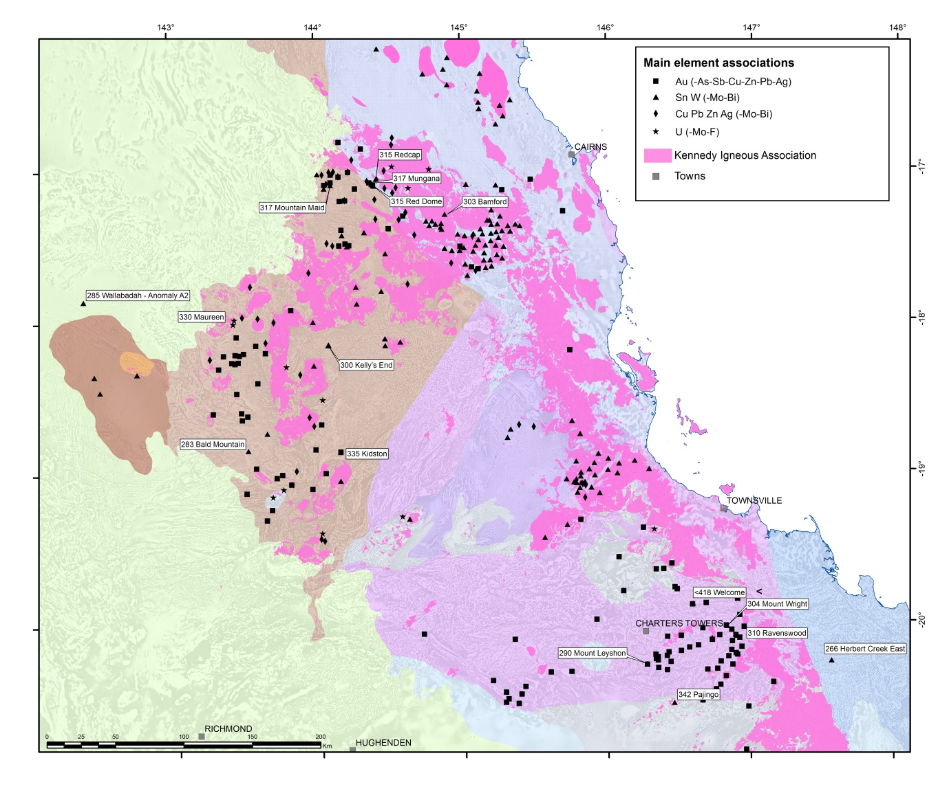

Figure 2: Map of both the intrusion-related mineral camps and the spatial extent of the Kennedy Igneous Association. This map highlights the lack of direct spatial relationship between known mineral deposits and mappable (at a 1:100k scale) intrusive bodies. This figure also demonstrates the Au-Sn-W-Mo-U character of mineralisation and the lack of known Cu deposits, except for mafic volcanic host domains like Chillagoe.

Current projects
To address some of the critical information gaps and to evaluate and reduce exploration risks, the GSQ, along with James Cook University (JCU), Terrasearch Exploration (TS) and Klondike Exploration (K), are undertaking the North Queensland Magmatic Systems Study under the Future Resources Industry Priority Initiative. The $2.5 million initiative, including in-kind contributions from the program collaborative partners and additional funding from industry, runs over three years and finishes mid-2017. The project has industry support from Evolution Mining, Carpentaria Gold, Vital Metals and Glencore – Copper, along with support on the ground from numerous other exploration companies working in the area. The North Queensland Magmatic Systems Study aims to provide new insights into the Cu-Au porphyry associations with high-sulfidation epithermal deposit (specifically looking at the Mount Carlton mine within the northern Bowen Basin), as well as an updated interpretation of the geology and the mineral potential of the Charters Towers Province and the tin-tungsten bearing granites of north Queensland. The larger project is split into 11 sub projects (Table 1), with the eventual goal of producing a regional prospectivity model incorporating new concepts and methodologies that explorers can test within both greenfields and brownfields regions of north Queensland.

Project Title | Responsible group
1. Magma-related hydrothermal mineral systems of the northern Bowen Basin | JCU
2. Geology of the Mt Carlton high-sulfidation epithermal deposit | JCU
3. Magma fertility, petrogenesis and geodynamic setting of Carboniferous and Permian magmatic complexes | JCU
4. Updated geology of the Charters Towers region | TS-K
5. Metallogeny of the Charters Towers Province | TS-K
6. Metallogeny of the Permo-Carboniferous mineral systems of the Georgetown region | TS-K
7. Metallogeny of Sn-W-Mo-Cu mineral systems | JCU
8. Exploration geophysical signatures of intrusion-related deposits in the Charters Towers region | TS-K
9. Comprehensive prospectivity analysis | JCU - GSQ
10. Regional alteration mapping using remote sensing methods | JCU
11. Geochemical signatures of intrusion-related mineral systems | JCU - TS-K

There will be staged releases of the North Queensland Magmatic Systems Study, with a final report including a prospectivity assessment of north Queensland based on the new concepts and data to be released in 2017.

Future Research
Ongoing work within the GSQ includes the Cape York Mineral Assessment project, a 3 year project finishing in 2016, focusing on infilling the previous National Geochemical Survey of Australia (NGSA) within north Queensland and linking the anomalous results to existing or highlighting new areas of potential mineralisation. The project is also a natural extension of the North Queensland Magmatic Systems Study as the Kennedy Igneous Association extends into Cape York as far north as the Torres Strait, where the Carboniferous-Permian Horn Island mine historically produced 1819kg of gold (von Gnielinski, 2015) with an associated base metal mineralisation and a fluorite-(tin-tungsten) overprint. The relationship between the goldfields and tin-tungsten fields of the Cape York and the most northern extent of the KIA intrusives will be used to further understand the regional context of the Carboniferous to Permian mineral systems within the larger north Queensland project to the south.

References
Blevin, P.L., 2004: Redox and compositional parameters for interpreting the granitoid metallogeny of eastern Australia: Implications for gold-rich ore systems. Resource Geology 54, 241-252.
Blevin, P.L., 2010: Intrusion related gold deposits. Geoscience Australia, Canberra.
Champion, D.C., 2007: New insights into intrusion-related mineralisation in the Tasmanides. In Proceedings, Digging Deeper V, Geological Survey of Queensland Seminar, Bardon Conference Centre, Mount Cootha 28th November 2007 and Townsville (JCU) 3rd December 2007. Geological Survey of Queensland, Brisbane.
Champion, D. & Blevin, P., 2005: New insights into intrusion-related gold-copper systems in the Tasmanides. Presentation at Mining 2005, Brisbane, 26 October 2005. Geoscience Australia, Canberra.
Champion, D.C. and Bultitude, R.J., 2013. Kennedy Igneous Association. In: Jell, P.A. (ed) Geology of Queensland. Geological Survey of Queensland, Brisbane, pp 473–514
Kositcin, N., Champion, D.C. & Huston, D.L., 2009: Geodynamic synthesis of the north Queensland region and implications for metallogeny. Geoscience Australia Record 2009/30.
Morrison, G., Lisitsin, V., and Dhnaram, C., 2015. Intrusion-Related Gold Systems of North Queensland, Australia. SGA 2015 Abstract.
von Gnielinski, F., (Compiler) 2015. Queensland Minerals 2014, a summary of major mineral resources, mines and projects. Department of Natural Resources and Mines, Queensland.
Withnall, I.W., Henderson, R.J., Champion, & Jell, P.A., 2013. Chapter 1 Introduction. In: Jell, P.A. (Editor): Geology of Queensland. Geological Survey of Queensland, Brisbane, 1–21.

